1. On the frog diagram below, the structure labeled "a" is
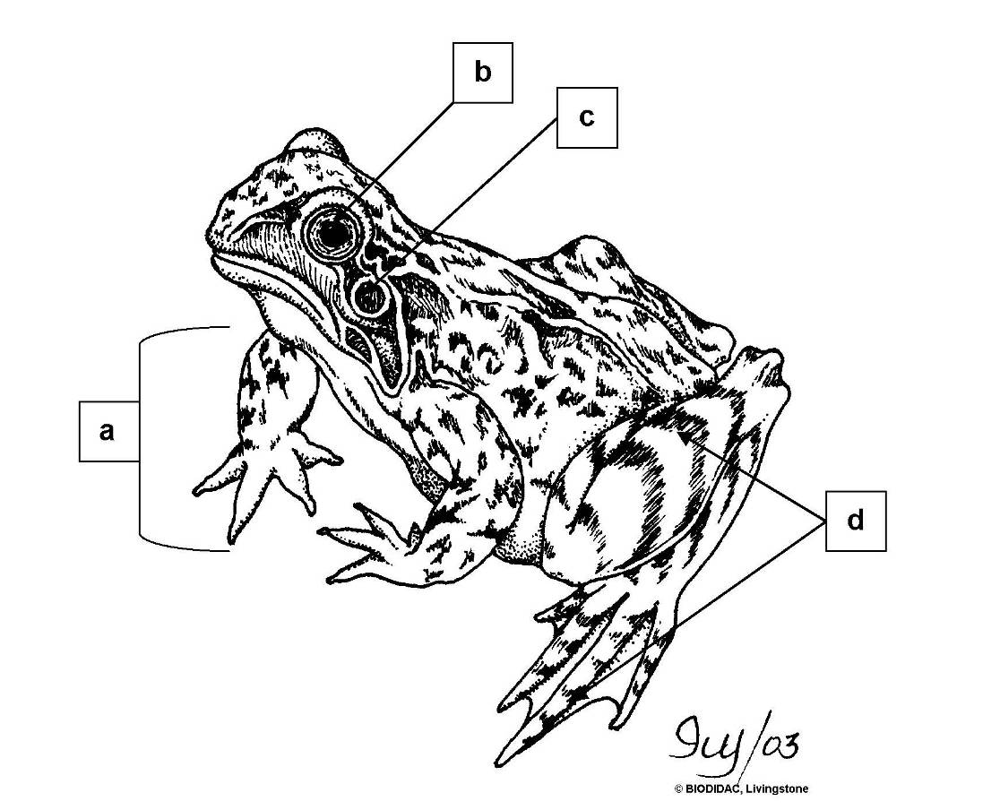

a. eye
*b. forelimb
c. hindlimb
d. tympanic membrane

2. On the frog diagram below, the structure labeled "b" is

*a. eye
b. forelimb
c. hindlimb
d. tympanic membrane

3. On the frog diagram below, the structure labeled "c" is

a. eye
b. forelimb
c. hindlimb
*d. tympanic membrane

4. On the frog diagram below, the structure labeled "d" is

a. eye
b. forelimb
*c. hindlimb
d. tympanic membrane

5. On the frog diagram below, the structure labeled "a" is
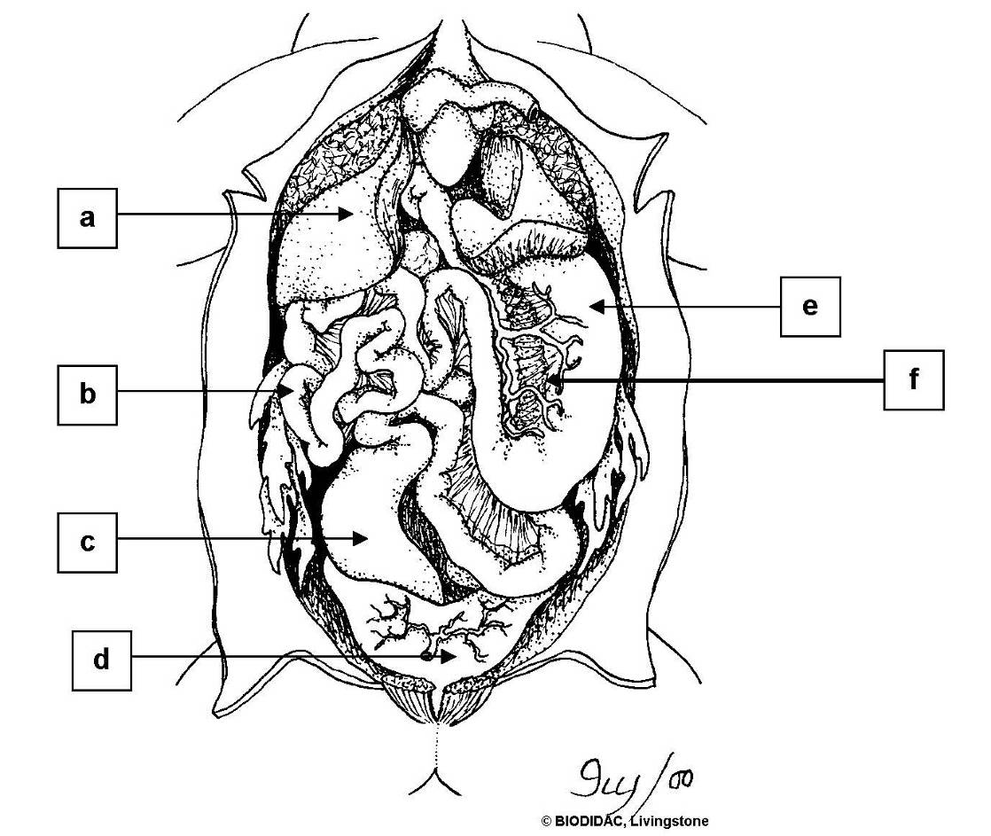

a. large intestine
*b. liver
c. pancreas
d. small intestine
e. stomach
f. urinary bladder

6. On the frog diagram below, the structure labeled "b" is

a. large intestine
b. liver
c. pancreas
*d. small intestine
e. stomach
f. urinary bladder

7. On the frog diagram below, the structure labeled "c" is

*a. large intestine
b. liver
c. pancreas
d. small intestine
e. stomach
f. urinary bladder

8. On the frog diagram below, the structure labeled "d" is

a. large intestine
b. liver
c. pancreas
d. small intestine
e. stomach
*f. urinary bladder

9. On the frog diagram below, the structure labeled "e" is

a. large intestine
b. liver
c. pancreas
d. small intestine
*e. stomach
f. urinary bladder

10. On the frog diagram below, the structure labeled "f" is

a. large intestine
b. liver
*c. pancreas
d. small intestine
e. stomach
f. urinary bladder

11. On the female frog reproductive system diagram, the structure labeled "a" is
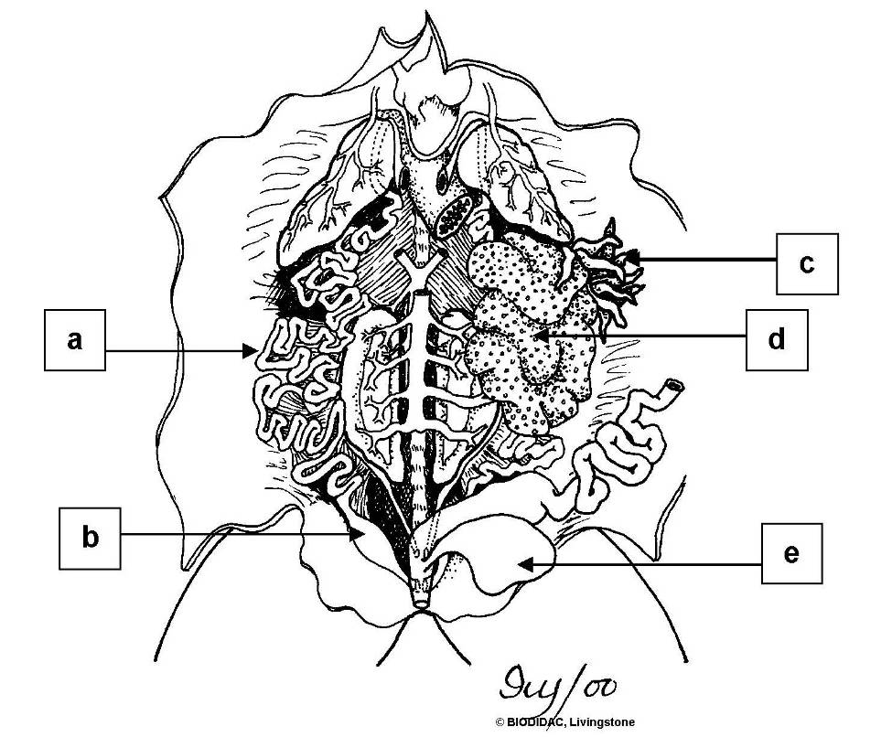

a. fat body
b. ovary
*c. oviduct
d. urinary bladder
e. uterus

12. On the female frog reproductive system diagram, the structure labeled "b" is

a. fat body
b. ovary
c. oviduct
d. urinary bladder
*e. uterus

13. On the female frog reproductive system diagram, the structure labeled "c" is

*a. fat body
b. ovary
c. oviduct
d. urinary bladder
e. uterus

14. On the female frog reproductive system diagram, the structure labeled "d" is

a. fat body
*b. ovary
c. oviduct
d. urinary bladder
e. uterus

15. On the female frog reproductive system diagram, the structure labeled "e" is

a. fat body
b. ovary
c. oviduct
*d. urinary bladder
e. uterus

16. On the male frog reproductive system diagram, the structure labeled "a" is
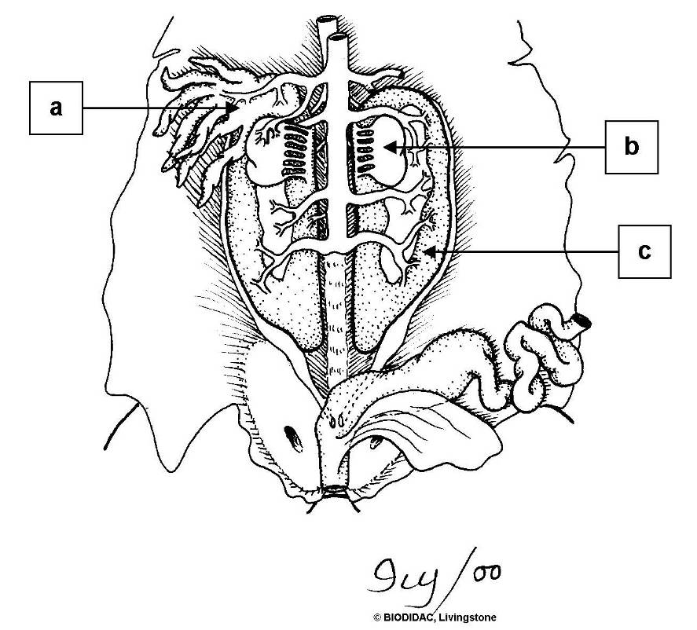

*a. fat body
b. kidney
c. testis

17. On the male frog reproductive system diagram, the structure labeled "b" is

a. fat body
b. kidney
*c. testis

18. On the male frog reproductive system diagram, the structure labeled "c" is

a. fat body
*b. kidney
c. testis

